S3 Conference 2022: Call for Abstracts and Proposals
The Call for Submissions of Abstracts and Proposals for the S3 Conference is now open. The Organising Committee invites professionals involved in healthcare-related simulation activities to submit their abstract/proposals for the following:

- Experimental Studies – e-Poster Presentation
Abstracts describing experimental studies.

- Observational Studies – e-Poster Presentation
Abstracts describing a methodology or educational program.

- Workshops
A session to facilitate discussion and collaboration among participants. Interactivity for participants is highly recommended.

- Expert Panels
A panel discussion gathering 3 to 5 experts to discuss a specific topic in healthcare simulation. Interaction with the audience is strongly recommended.

Important Dates to Note

Call for Submission of Abstracts and Proposals | : 26 January 2022 – 07 April 2022*
Submission of Abstracts and Proposals Closes | : 07 April 2022*
Submitters Notified on Outcome | : By 17 June 2022*
NOTE: All presenters are required to confirm their attendance as PAID/ REGISTERED delegate upon abstract/proposal acceptance.
Acceptance of Outcome by Shortlisted Submitters | : 15 July 2022*
*Please note that the submission date is according to Singapore Standard Time (GMT +8)

Guidelines for Submission
Failure to observe these guidelines may result in disqualification

General Information
- Please note that this is a one-time submission and all information should be readily available before you proceed with the submission. For any amendments after submission, please send in latest by 07 April 2022.
- All submissions must be in English.
- Your abstract(s) and/or Poster(s) will be uploaded onto S3 Conference 2022 publicity platforms.
- Your Workshop and/or Expert Panel programme details will be uploaded onto S3 Conference 2022 publicity platforms.
- The title of the abstract/proposal should be concise. Trade names cannot be mentioned in the title. However, trade names in brackets will be accepted in the body of the text.
- The abstract/proposal will be considered and scored based on the content category selected:
- Centre Management & Technical Operations
- Assessment Using Simulation
- Curriculum Design & Development
- Faculty Development & Debriefing
- Patient Safety & Quality Improvement
- Integration of Research in Simulation
- Inter-professional Education
- Technology & Innovation
- Details of presenting author(s) MUST be given. Other presenters (for workshops/expert panels) can be confirmed when the abstract/proposal is accepted.
- Please ensure that the workshop/expert panel must be readily available in both virtual and physical mode. This is in the event that the physical session cannot be held, the virtual session can still proceed.
- The use of standard abbreviations is desirable. Place special or unusual abbreviations in brackets after the full word the first time it appears. Use numerals to indicate numbers, except to begin sentences.
- Please ensure the submitted abstract/proposal does not contain spelling, grammatical or scientific errors. Abstracts will be reproduced exactly as submitted, and no proof reading will be undertaken.
- Abstracts/Proposals should be submitted by the submission deadline: 07 April 2022.
- All presentation rooms are equipped with the following AV equipment: 1 Projector, 1 Windows‐based Laptop with internet capabilities, MS Office 2016 (Word, Powerpoint, Excel), 2 hand-held microphones (hands-free microphones are subject to availability)

Submission Format
Experimental Studies – e-Poster Presentation
- Fill in the appropriate sections of the abstract:
  - State Introduction & Aim(s) of study.
  - State Method(s) and subject used, where relevant.
  - Results – Summarise result(s) obtained. It is not satisfactory to state, "The result will be discussed".
  - Discussion – Discuss and state conclusion(s) reached.
- Abstracts should preferably not exceed 600 words.
- The use of tables, graphs and other types of images in abstracts is not permitted.

Observational Studies – e-Poster Presentation
- Fill in the appropriate sections of the abstract:
  - State Introduction & Aim(s) of study.
  - Provide Description.
  - Discussion – Summarise and discuss. It is not satisfactory to state, "The result will be discussed".
- Abstracts should preferably not exceed 600 words.
- The use of tables, graphs and other types of images in abstracts is not permitted.

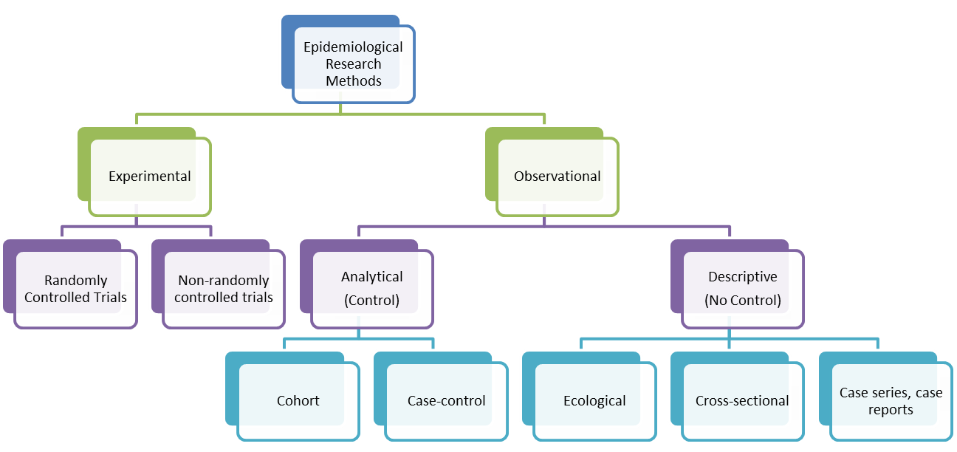

Submission Format

Workshops or Expert Panel
- Fill in the appropriate sections of the proposal:
  - State the Motivation for Programme. (i.e. rationale, objectives, etc)
  - Provide the details under Programme Description on how the session will be conducted, including the organising and sequencing of the programme.
  - List down the Learning Outcomes.
  - Include the Target Audience for the session, especially if there are any prerequisite level of knowledge/experience relating to the topic required.
  - Provide details under Programme Outline on how the session will be conducted, including the organising and sequencing of the programme.
- Proposals should not exceed 800 words for (c) to (e).
- The use of tables, graphs and other types of images in proposals is not permitted.
- Presenters should make arrangements on their own, if materials are required (i.e. course notes, moulage materials, softwares, etc), for their proposed activities.
- Any cost incurred when conducting the session will be borne by the presenters.
- Equipment and supplies (i.e. manikins, task trainers, laptops, softwares, etc) needed are subject to availability. The Secretariat will work with the presenters if the desired equipment/supplies are not available for the session.

Withdrawal Request
If you wish to withdraw your submission already submitted, please notify us at s3@singhealth.com.sg stating the title and reasons for withdrawal by 07 Apr 2022.

Enquiries
For enquiries on submission, please contact the event secretariat at s3@singhealth.com.sg.

