Grants Best Practices User Guide

COMMERCIAL

-

IN

-

CONFIDENCE



*F1 Solutions*

*User Guide*

*Grants Best Practices*

April

202

4



Level 1

,

103

Northbourne Ave

Turner ACT 2612

www.f1solutions.com.au | T: 02 6245 7999

© Copyright F1 Solutions

Table of Contents

Frequently Asked Questions 2

7.1 How do I manage my Account Settings? 2

7.2 How do I access the External Portal? 3

7.3 I’ve forgotten my password 3

7.4 My application was rejected how do I speak to someone? 5

# Frequently Asked Questions

# 7.1 How do I manage my Account Settings?

1. Log into the External Portal and select **Profile** within the top horizontal navigation menu.

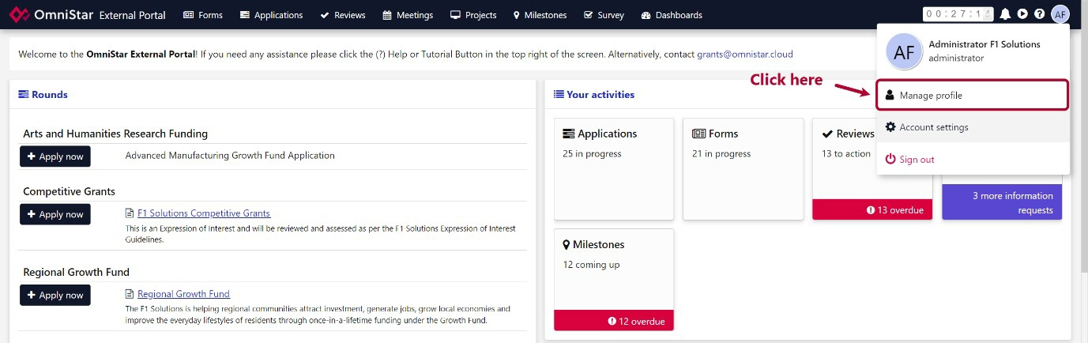

1. Select **Account Settings** from the vertical navigation menu on the left.

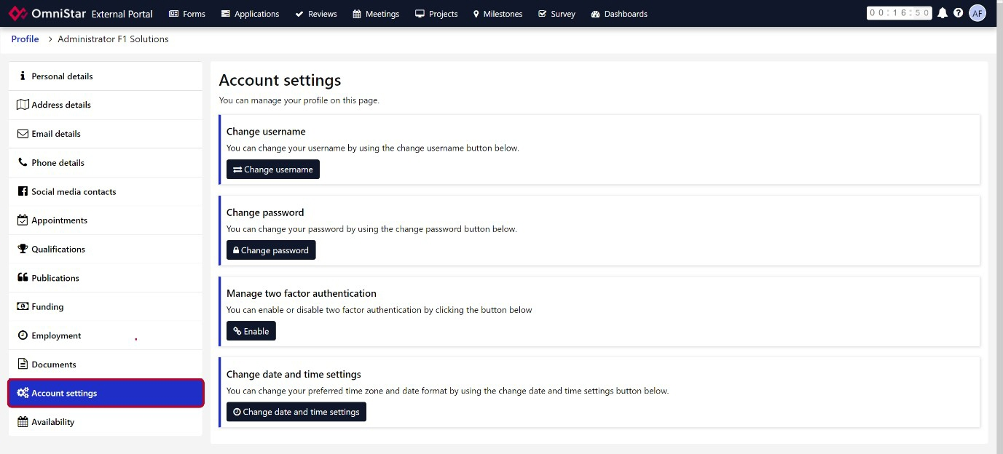

1. Here you can change your **username**, **password** or **delete** your account.

# 7.2 How do I access the External Portal?

1. You can log in using: <https://amgrants.duke-nus.edu.sg/>
2. If you do not yet have an account please refer to the “Registration to AMgrants system” guide.

# 7.3 I’ve forgotten my password

1. If you are having trouble logging in, there are links to reset your password or register for an account at the bottom of the [log in screen here](https://amgrants.duke-nus.edu.sg/)[.](https://avantomnistar.f1solutions.com.au/)

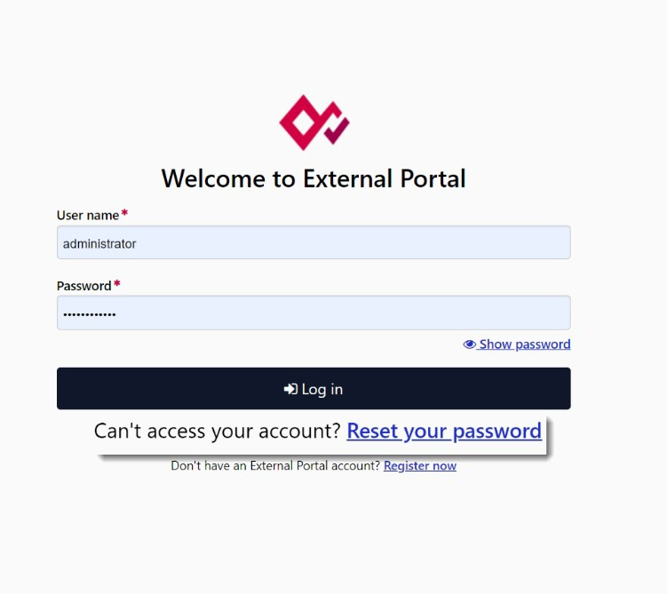

1. Enter your username into the textbox, select “**I’m not a robot**” and click **Reset password**.

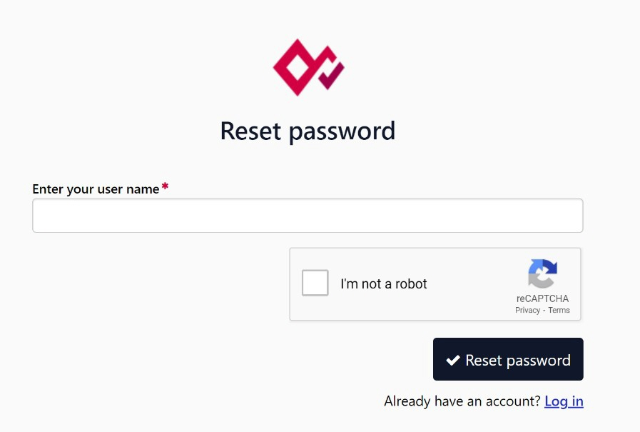

1. A confirmation message should be displayed. Click **Return to logon page** to log in.

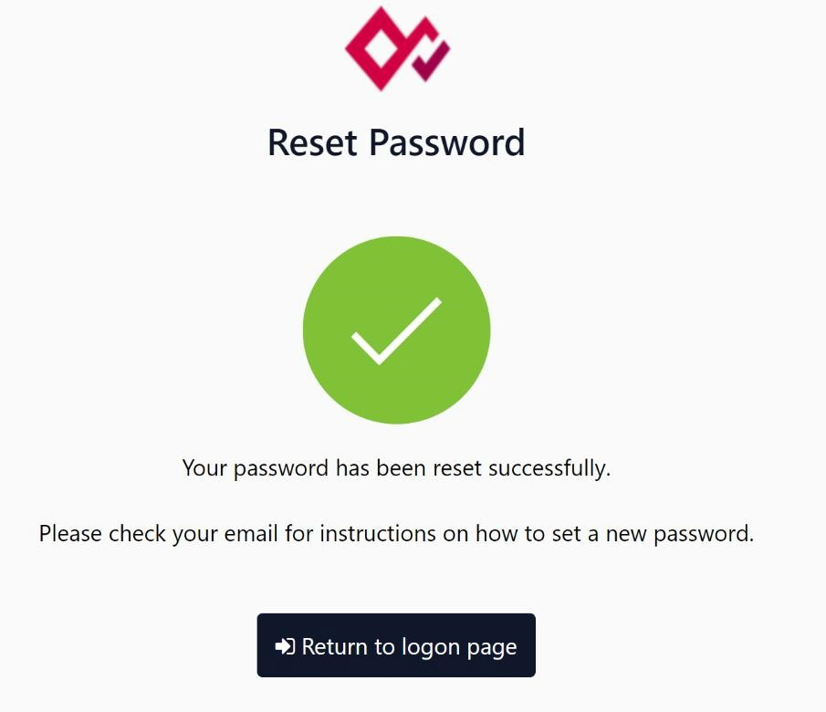

1. Check your email account associated with your user. A reset password email should be present. Open the email and click the link embedded in the email.

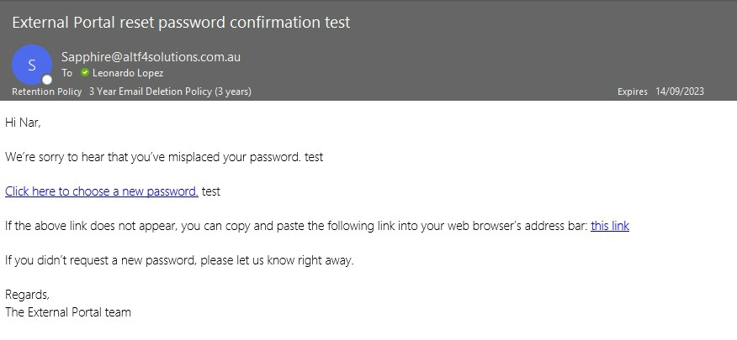

1. A new browser window will be opened showing the change password screen. Enter a new password.

# 7.4 My application was rejected how do I speak to someone?

Please contact your JOAM point-of-contact.