User Guide

–

DUKE

–

National University of Singapore



User Guide

DUKE

–

National University of Singapore

—

January 2025



User Guide



User Guide – DUKE – National University of Singapore

# Application Form Submission – External Portal

1. Applicants can start an application by navigating to the External Portal and clicking ***Apply Now*** under ***Rounds*** (this section displays a list of active rounds), for the specific program and round they wish to apply for.

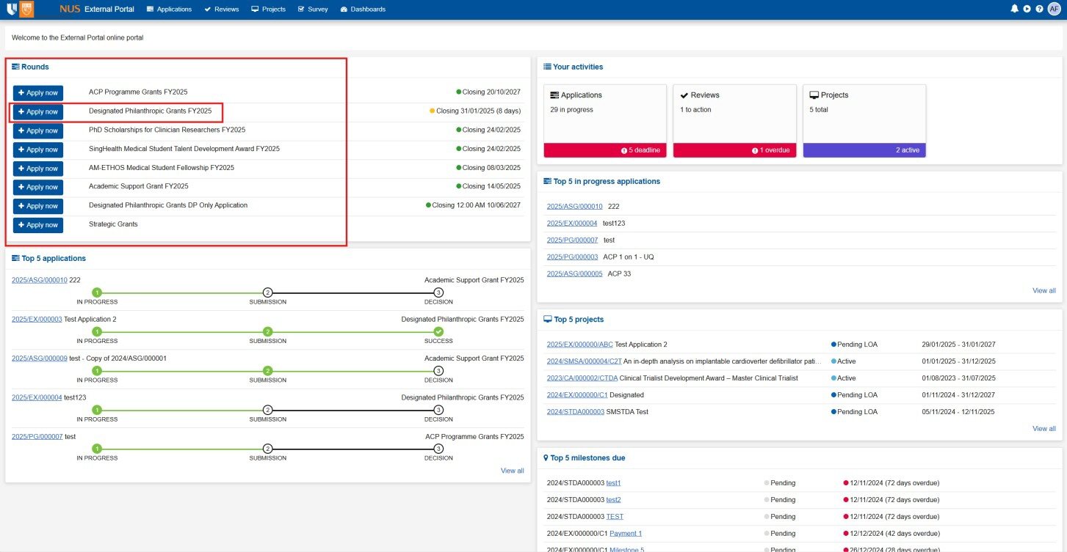

1. This takes the applicant to the form; the applicant can fill this form and provide relevant certifications.
2. The Principal Investigator or application owner also has the option to invite users to this application form (with the option to choose read or write access). This will be needed for certifications
3. This is done by clicking on the **Invite user to register or share application** button.

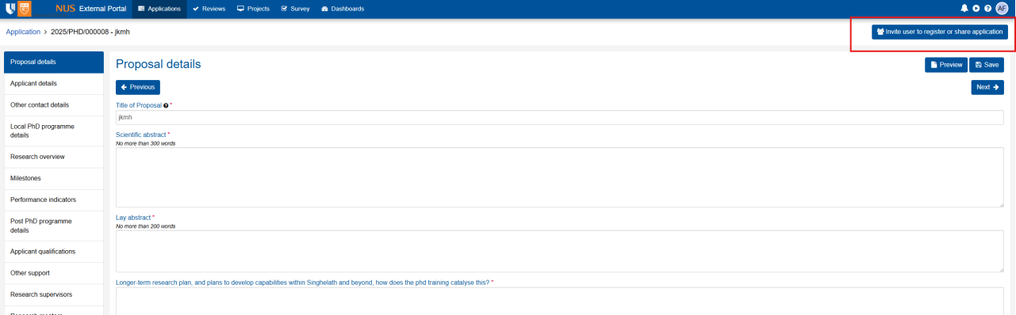

1. After clicking this button, the Activity lead needs to enter the username for the user to be invited, once this is done and the Activity lead clicks ***Save and send*** – the system will send an invitation email to the user. They will be able to access the form using the link provided on the invitation email.
   * Non-disclosure agreement
   * Conflict of Interest
   * Populating the Review form and submitting it with scores based on different criteria

# Variations

Create a variation – External Portal

1. Applicants can request changes in project dates, contacts, milestones and other information through submitting the variation form in the External Portal through clicking ***Project*** -> ***Variation > New Variation.***

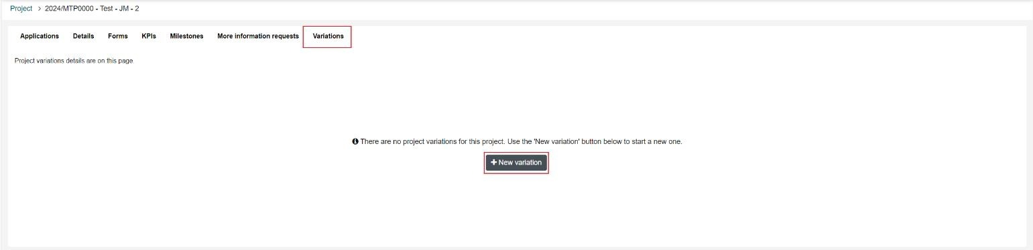

1. After clicking ***New variation***, applicants are required to input on *variation title*, select the *variation type and* click ***Done****.*

1. Applicants will need to fill in all required fields and click ***Submit*** to submit the variation form.

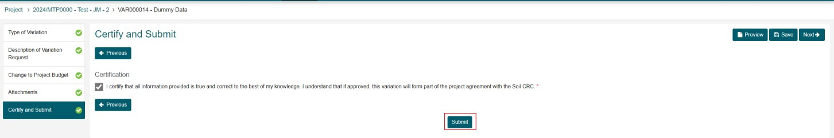

**Note:** Applicants can download the project variation form (output document) through ***Preview.***