Self-Registration for Local Account

Step 1: Click “Register Now”
You will receive an email from the AMgrants to activate your account
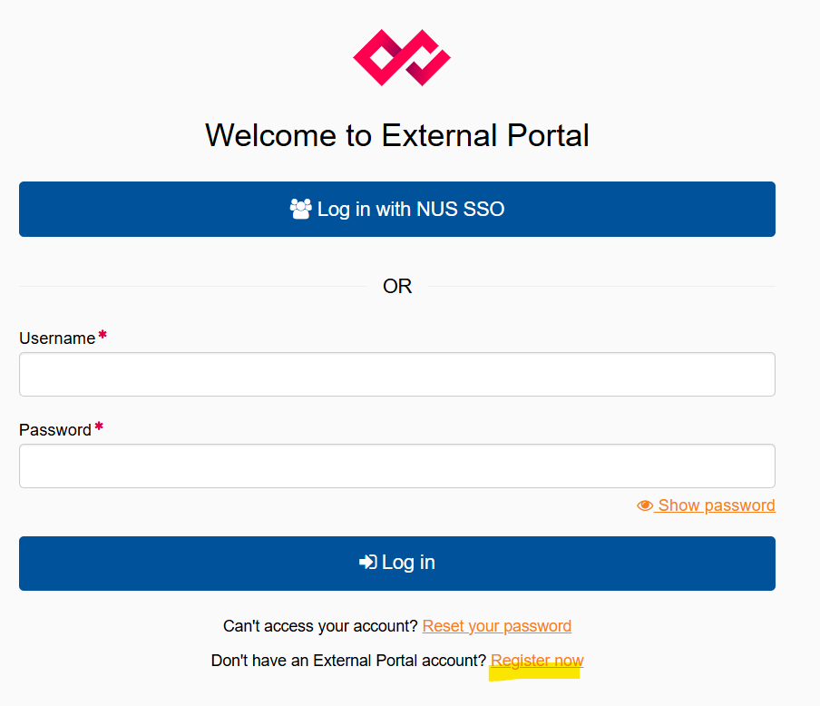

Step 2: Refer to the email and activate your account
You will receive an email from the AMgrants to activate your account
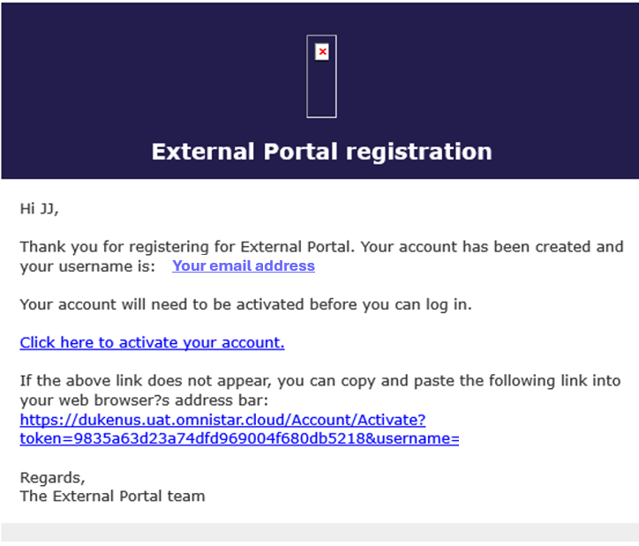
Step 3: Set up the Google or Microsoft Authenticator.
Key in the one-time password after you set up the multifactor authentication.

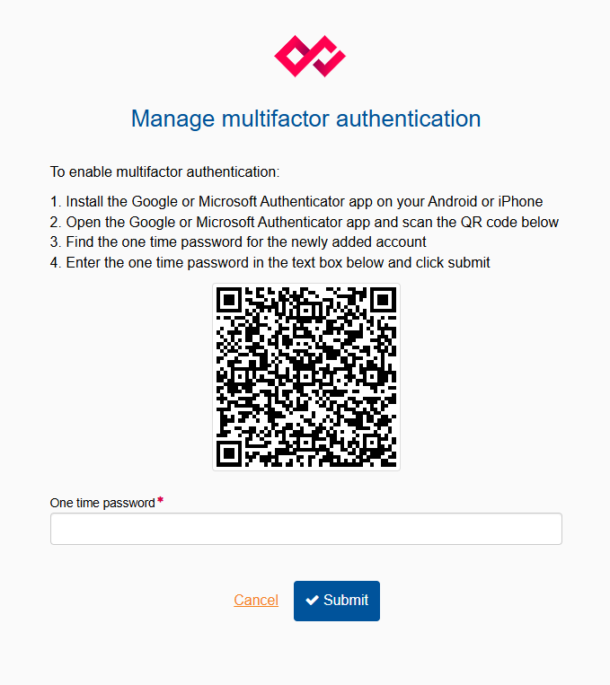
Step 4: Click on the “agree” button
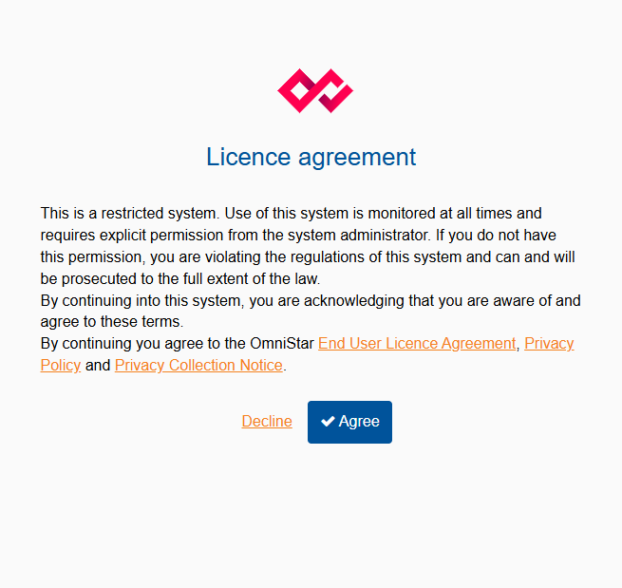

Step 5: You will now arrive to the login page
Login page with overview of ongoing rounds, applications and projects.
