Discuss the kinds of ethnobotanical techniques deployed to navigate gendered life stage experiences.
In this essay, I articulate the use of herbal therapy in Traditional Chinese Medicine(TCM), 中药, as an ethnobotanical technique used by TCM practitioners to help heterosexual women and men of reproductive age navigate challenges in reproduction in Beijing, urban China in the late 20th century. In the first section, I situate discussions of body and gender in ethnobotany, and the conception of the body in TCM as ‘androgynous’ with Qi, 气, and yin-yang, 阴阳, cosmologies. In the second section, I contemporise the discussion of TCM and argue major post-Mao economic reforms have led to ‘sexed bodies’ leading to pathologisation of reproductive disorders. Accordingly, ethnobotany has had a shifting role from improving well-being to medical cure. With the introduction of ‘Western medicine’, 西药, and Artificial Reproductive Therapy(ART) the role of ethnobotanical techniques while now as an adjunct therapy, remains ever relevant.
Ethnobotany and Body
Ethnobotany is ‘interdisciplinary science that combines anthropology and botany’(Prance 1991:210) which studies ‘the interactions and interrelationships between people and plants as mediated through culture(my emphasis)’(Edwards 2023:9). Ethnobotany cannot be reduced to the use of plants as pharmaceutical therapy. Pharmacology, the study and development of pharmaceutical therapies, relies on the branches of biomedicine such as molecular pathways, biochemistry, physiology (Nichter and Vuckovic 1994). Instead, plants in ethnobotany might be ‘effective’ because of the meaning within its culture(Moerman 2007).
In defining ethnobotanical techniques, I borrow Marcel Mauss’s bodily techniques described as ‘the ways in which from society to society, men know how to use their bodies’(Mauss 1973:70). Bodily techniques, can also be viewed as a methodological approach to ‘move from the concrete to the abstract and not the other way round’(Mauss 1973:70). I extrapolate and define ethnobotanical techniques as the ways individual societies know how to use plants, and a means to understand a society better. I intentionally draw this connection, as understanding ethnobotany requires an understanding of the body.
Body, Sex and Gender
Gender is mostly understood through Judith Butler’s notion of performativity in which gender becomes a natural identity through the repetitive performing acts in accordance to a gender that is acknowledged and accepted by a society(Butler 1990:xv). ‘Sexual differences demand social recognition and representation… no amount of technological innovation or ideological equalization can disavow or overcome’(Grosz 1994:18) Stephanie Grosz writes in Volatile Bodies. Grosz is responding to social constructivist feminists who understand femininity ‘purely as a social, cultural and signifying effect lacking its own weighty materiality’(Grosz 1994:21). Feminists in turn were responding to the justification of patriarchal oppression where the ‘mind is rendered equivalent to the masculine and the body equivalent to the feminine’.(Grosz 1994:14). While men are defined by their production of knowledge, women are through the female bodies’ reproduction of bodies(Grosz 1994:13).
Hence, in this essay on gendered life stages and ethnobotanical techniques, I directly deal with the ‘sexed bodies’ to understand gender through the body in its socio-political-historical context in relation to biology(Grosz 1994:187) in its greatest site of contestation: Reproduction.
The Body in Traditional Chinese Medicine(TCM)
TCM was institutionalised after the 1949 founding of the People’s Republic of China with the establishment of a united national front against Western medical modernisation(Farquhar 1994:12). In the early 20th century, TCM practitioners struggled against its elimination and replacement with ‘modern’ biomedical institutions(Farquhar 1994:13). Stretching further to the 17th century, ‘there was no term in Chinese for ‘Chinese medicine’(Lo and Stanley-Baker 2022:2) before the arrival of European medicine.
Yin-yang and Qi are core concepts of TCM today since Imperial China(Yun-Ju 2022:13). Yin-yang is the description of channels within the body. Excesses or blockages of channels will lead to disharmony of the balance of yin-yang and illness(Yun-Ju 2022:13). Qi is described as a flow of energy that separates the body with the world(Stanley-Baker 2022:39-44). With yin-yang, emphasis was put on the systematic function of the five viscera and six bowels.
Yin-yang are ‘the most important signifiers of bodily gender’(Furth 1999:46), where yin and yang represents female and male respectively(Figure 2). For instance, the sheng, 肾, kidneys, were considered to govern the reproductive function and contain jing, 精, ‘essence’ which manifests as semen in men, while the gan, 肝, liver stored ‘blood’, 血, which in TCM is described as a general type of bodily fluid containing life energy for fluids relating to reproduction such as menstrual blood and human milk(Yun-Ju 2022: 17).
TCM is related to cosmologies of the world where the five elements, 五行, wood, fire, earth, metal, water are used in medical reasoning(Hsu 2007:96). The body also is a microcosm of the imperial state and the state is a microcosm of the Cosmos. Hence, the imperial state which ruled each individual, was legitimized as a mandate from heaven(Lo 2022:2).
Ethnobotany in TCM
Herbal medicine is one of the most important TCM treatment technique(Goldschmidt 2022:133). Other TCM treatment techniques includes massage, acumoxa, acupuncture and qigong(Hsu 1999:9). Herbal medicine can either come as a drug, or a singular medicinal material, or formulae which are formed from a combination of drugs and are grouped according to major symptoms they treat(Goldschmidt 2022:134).
The Body, Gender, TCM
In A Flourishing Yin: Gender in China’s Medical History, Charlotte Furth, an American scholar of China, writes that in TCM there is not a ‘sexed body, but a ‘truly androgynous body’ with yin-yang as the ‘most important signifier[s] of bodily gender’(Furth 1999:46). Furth bases her analysis on the first century text Inner Canon where the ‘Yellow Emperor’s body is the ‘body of the generation’ and a ‘cosmologised entity that expresses the unity of the human being with the heavenly macrocosm’, and is ‘encompassed by the dyad of yin-yang which also orders the cosmos at large(Furth 1999:48). In the Inner Canon, sexual maturation of both sexes start with the development of the(Unschuld and Tessenow 2011: 36–8 as quoted in Yishan 2022:357). The womb was not seen as a ‘synecdoche for woman, nor a ruling feature of her constitution’(Bray 1995:237 as quoted by Yishan 2022:358). Sexual dimorphism and hence gender in the sexed body which presumes innate differences between the two sexes is not innate to the body in TCM.
Yin-yang instead is a mirroring position of male and female complementary roles in reproduction, rather than a marking of their bodies with gendered anatomy(Furth 1999:45 as quoted by Yishan 2022:358). With yin-yang, gender difference was not emphasised by TCM, except in diseases related to life stages of reproduction and childbirth(Raphals 1998:ch7).
Herbs and Reproduction in TCM
Mr Zhou, a twenty-six-year-old worker, could not satisfy his girlfriend because his penis was not rigid enough when erect. He had taken eight bottles of Huren shenbao (the popular patent herbal liquid that nourishes kidney yang and is thought to cure impotence)… before he saw a doctor of nanke at CUHTCM. The doctor asked him to try Yikanwans (“kan-benefiting pill”; kan is one of the eight divinatory symbols; it refers to water and corresponds to shen, the kidney, in Chinese bodily cosmology; the remedy thus can be described as “kidney benefiting”) and Viagra(Zhang 2015:186)
Sun, F-31. Examined December 4, 1980. Menarche was at age 15, menstrual periods tend to be delayed, volume of flow small and color pale, containing blood clots.… . In 1978 at another hospital iodized oil radiography was done of the uterus and fallopian tubes and the report was: "obstruction of both Fallopian tubes." Therapeutic plan is to warm the Kidney visceral system and nourish the Liver visceral system, regulate and replenish the Highway and Conception tracts, enliven Blood to eliminate stasis, regulate Qi to stop the pain. (He and Liu 1987:166-167 as quoted in Farquhar 1991:387)
Even though their disorders are vastly dissimilar, the focus of the treatment of both Mr Zhou and Ms Sun are similar in strengthening the liver and the kidney systems, and in regulating yin-yang systems and the Qi. Both Mr Zhou and Ms Sun are of reproductive age. Mr Zhou suffers from erectile dysfunction(ED), while Ms Sun suffers from ‘obstruction of both fallopian tubes’, which in biomedicine is termed hydrosalpinx. Infertility is not presented a a pathology, but as a ‘failure to achieve a desired bodily change’ and a ‘subtle deficiency of normal physiological functions’(Farquhar 1991:374). Examinations were repeated at every consultation, facilitating the therapeutic doctor patient relationship to determine the Qi and yin-yang of the kidney and liver systems, with the change in herbs in formulae(Figure 3). In both cases, during the consultations, the TCM physician examined the tongue, the pulse, and skin, and did not examine the genitalia directly. It was very rare for an infertility patient to be given a pelvic examination unlike in Western gynecology clinics(Farquhar 1991). Treatment for impotence included prescription for yangshengfang 养生方 , formulas for nurturing life, and yinwei,阴委, or shrinking of yin was the first recorded Chinese term in the Inner Canon.‘Childlessness is a consequence of exhausted virtue; it is a castration by heaven’, hence the failure to produce children was seen as a moral and religious, social issue where TCM physicians provided with moralistic and lifestyle advice(Handwerker 198:185). Hence, the immediate physical complaint of ED and infertility was seen as a symptom of a larger holistic health, rather than localised to the specific reproductive organs.
From a pharmacological perspective, the underlying mechanism of herbal treatment for ED is not fully elucidated, but have been suggested to include increasing testosterone levels, increase vasodilator levels, and reducing oxidative stress(Li, Jiang and Liu, 2017).
Fuke, Nanke, Sexed Bodies
In the post-Mao leadership with efforts to decollectivize, decentralize and privatise large sectors of the socialist economy to transform China into the world’s second largest economy. With female infertility and impotence turned from states of Qi deficiency, to pathological. Accordingly, sexual differences between female and male were reinforced.
With fears of a looming overpopulation crisis that would cripple economic growth, Chinese leaders instituted the one-child policy.(Handwerker 1998). Ironically, Chinese women felt greater pressure to have children. ‘the one child policy is really the “you must have one-child policy”, a Chinese childless woman plainly stated(Handwerker 1993), another remarked ‘everyone in the danwei has children and they are always asking me if I had one(Handwerker 1998:182). There was the assumption that all women of reproductive age will and should be fertile(Handwerker 1998:183). Hence, there is the transformation of a state of deficiency, into a state of physical pathology.
The danwei, 单位, work unit and hukou, 户口, household registration, systems are the two cornerstone systems of collectivist society implemented during the 1950s to 1960s Mao economic reform period that limited the flows of people with an urban-rural divide that allowed for the industrialisation and extraction of grain from the rural spaces. These systems were extremely rigid, and labour and money were also separated in a way that impeded the flow of sexual desire(Zhang 2015:53). Once employed in a danwei, which might be in a rural or urban location distant from their family, they might spend the rest of their life in the same danwei(Zhang 2015:56).With this legally married heterosexual couples were separated for decades. Long-term sexual abstinence could result in the loss of the ability to get an erection(Sandfort et al. 2008). Impotence, acquired ‘an epidemic of signification(Treichler 1987), with the emasculation of the social body(Farquhar 2002:269) and a denunciation of the failures of the past and the banality of the future for a China that has committed at every level … capitalist relations of reproduction(Farquhar 2002:274). In the immediate post-Mao economic reform period however, the significance of impotence changed from reproduction, with success of treatment the ability to have a child, to sexual pleasure(Zhang 2015:36).
妇科While Fuke had always existed to ensure the continuation of the familial (i.e. male) line, a pivotal principle of Confucian ethics (Waltner 1990:13), but has been argued to be the same as Chinese medicine’s central discipline of internal medicine, a body of knowledge and practices that concerns itself with all physiological and pathological processes(Farquhar 1991:374). NanKe男科, was established in 1983, impotence was the most prominent concern among patients, and a visible sign of nanke’s work to Chinese people. Medicalisation and production of Erectile dysfunction as a disease.
‘It is not a matter of suffering an illness, it is the story of how each woman suffers history, a sense of suffering transmitted from generation to generation, and one that is experienced exclusively by women’(Pandolfi 1991:63), Anthropologist Mariella Pandolfi notes that women talk of historical events, both personal and national, through their bodies. Pandolfi argues that by centering knowledge developed from women, who have been peripherialised in knowledge creation, historical narratives that are contrary to a community’s dominant narrative emerges. Hence, history becomes embodied within women’s bodies, and women’s bodies become sites of medicalisation. With the pathologisation of ED in China, I instead show how historical experiences are also embodied by men.
Shifting role of Ethnobotanical Techniques
The doctor asked him to try Yikanwan and Viagra. During the following ten months, Mr. Zhou took ten Yikanwan pills every day for an extended period of time. He also took eight Viagra pills during the ten months. When he returned to the hospital, Mr. Zhou reported that he was able to have sex once a week. The eight Viagra pills he had taken seemed to have boosted his confidence when having sexual intercourse with his girlfriend. But he also said that the ejaculations he had after taking Viagra were not satisfying: “She le jiu she le, meiyou ganjue” (射了就射了, 没有感觉, I ejaculated for the sake of ejaculation but did not feel anything). (Zhang 2015:186)

Ethnobotanical techniques are influenced by the conceptions of the body. With changing conceptions of the body, so does the role of ethnobotany shifts. The Westernisation of TCM through its institutionalisation, also came with it the medical pluralism.
Viagra was introduced as a treatment for erectile dysfunction in China in the early 21st century. TCM doctors needed to learn how to navigate herbal medications alongside with Viagra. For Mr Zhou, herbal medicine now had to coexist with Viagra, leading to a ‘hybridised form of healing’(Zhang 2015:186). Doctors neded to ask patients to temporarily stop taking Viagra in order to let herbal pills take effect in order to evaluate the efficacy of either treatment. “Chinese medicine produces better efforts in improving sexual desire and controlling ejaculation … improves the general status of the body, whereas Viagra can improve the rigidity and frequency of erections” Dr Jia a biomedical doctor(Zhang 2015:186) commented. Viagra does not work without sexual desire.
Contrary to biomedical expectations, the response was disappointing that counter the hegemonic reduction. ‘The reluctance of maby Chinese men to adopt Viagra involved an understanding of potency that went beyond the simply ability to achieve an erection’, as potency in terms of one’s overall vitality, that had to be cultivated methodically over the long run and should not be suddenly induced when is needed, the resilience of TCM to yangsheng(Zhang 2015:18).
Ms Sun was able to have a healthy child, after being married for 8 years without pregnancy., and her attempt at western medicine. Even though for Ms Sun, hydrosalpinx would normally be treated with an invasive procedure, the TCM treatment defies biomedical anatomy to find treatment. TCM for female infertility are suggested to be more effective in the treatment than standard Western Medical drug treatment, over a shorter period of time(Ried and Stuart 2011). ‘Chinese medical thinking is not naturally murky, it just gets that way when one attempts to fill its intellectual objects with anatomical content’(Farquhar 1991:385).
Conclusion
In 1988, the media announced the birth of the first Chinese by ART. In 2016, the Chinese government revoked the one-child policy, to allow two children, and again in 2021 to allow three. Hanwerker discusses the contradiction in the use of female bodies as symbols of modernity and progress, while overly reproductive women are encouraged to undergo sterilisation, infertile women are stigmatized. Now The form of ethnobotany shows that there is no contradiction here. Now, Cuscuta chinensis Lam. (Tusizi) is the most commonly used herb to treat kidney disease in female infertility. The effect of herbal medicine led to a significant increase in pregnancy rates compared to the placebo treatment.(Hyun, Jung and Park, 2024)

Figures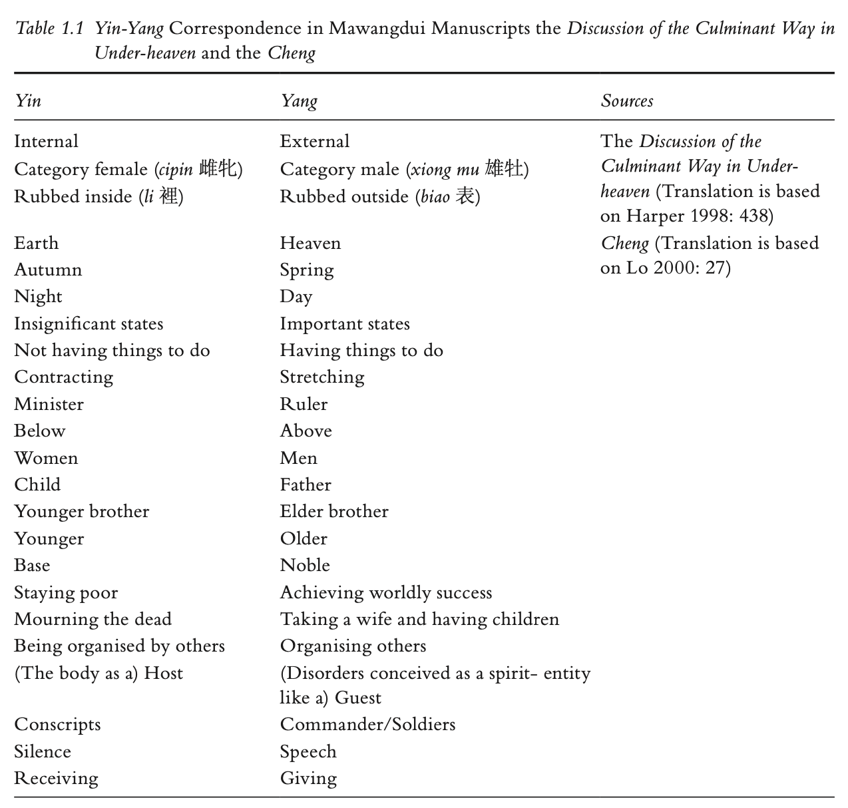
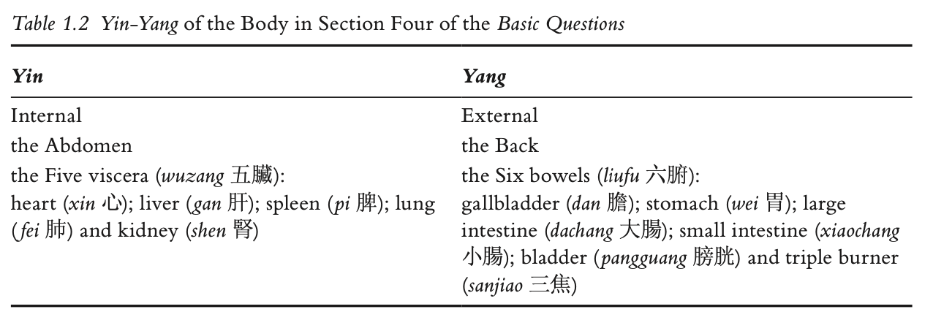

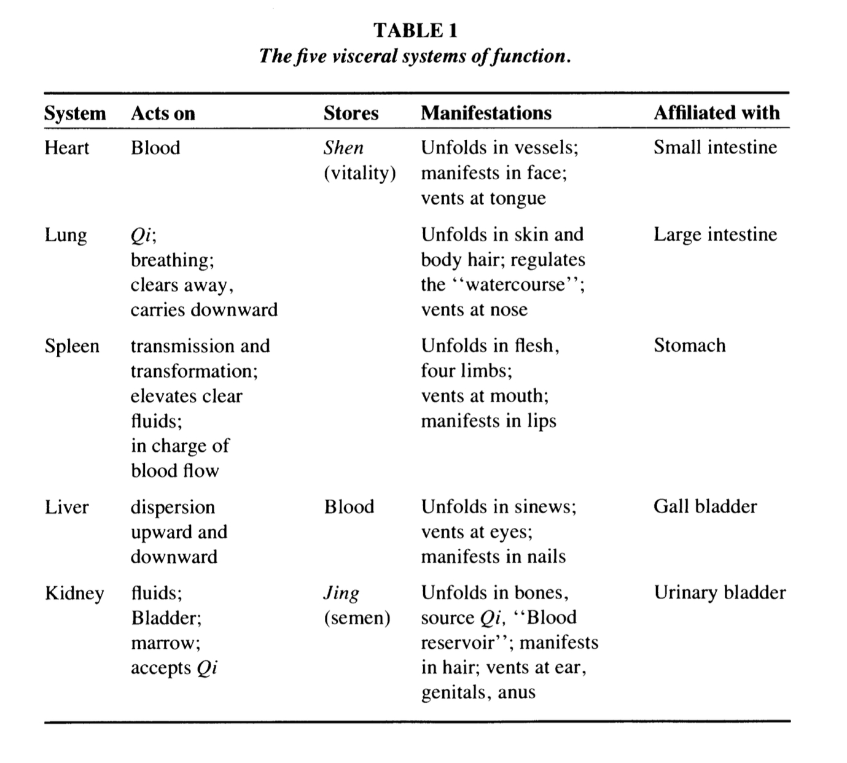
(Farquhar 1991:376)
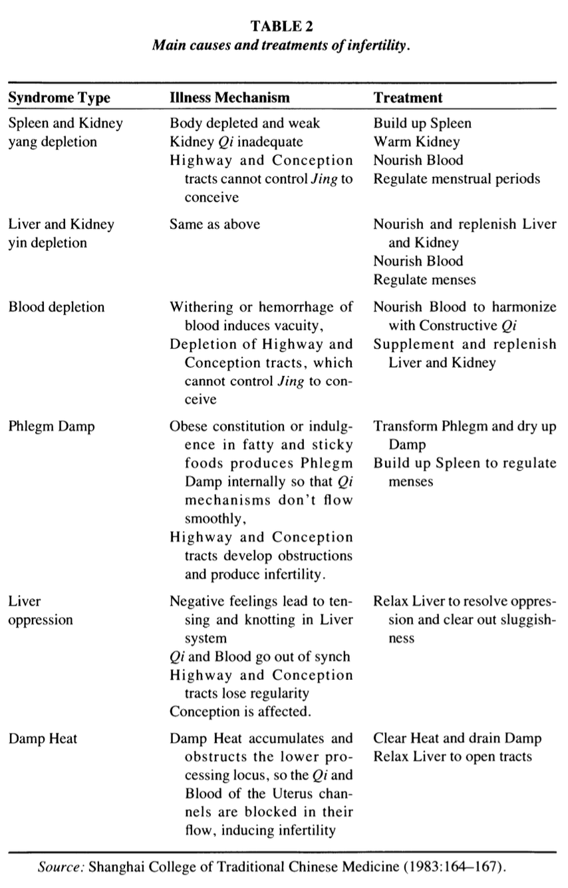
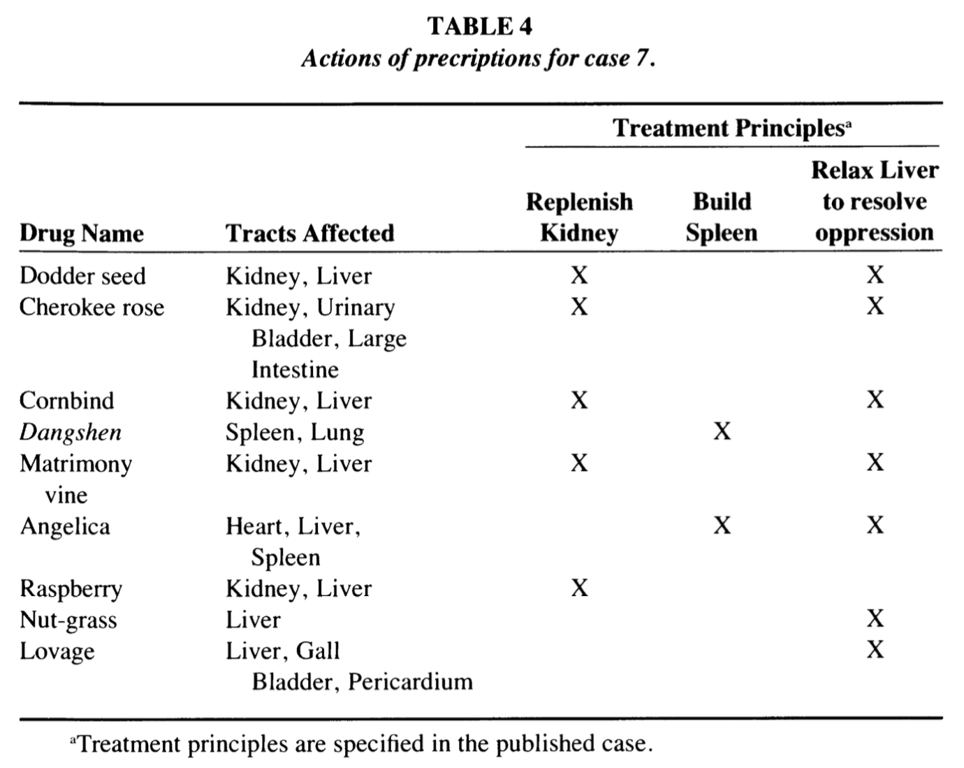
(Farquhar 1991:384)

Bibliography
Bray, F. (1995) ‘A deathly disorder: understanding women’s health in late imperial China’, in D. Bates (ed.) Knowledge and the Scholarly Medical Traditions. Cambridge: Cambridge University Press, pp. 235–250. Available at: https://doi.org/10.1017/CBO9780511621666.011.
Butler, J. (1990) Gender trouble: feminism and the subversion of identity. New York ; Routledge (Thinking gender).
Edwards, S. (2023) The ethnobotanical: a world tour of indigenous plant knowledge. London: Greenfinch.
Farquhar, J. (1991) ‘Objects, Processes, and Female Infertility in Chinese Medicine’, Medical Anthropology Quarterly, 5(4), pp. 370–399. Available at: https://www.jstor.org/stable/649292 (Accessed: 26 May 2024).
Farquhar, J. (1994) Knowing practice the clinical encounter of Chinese medicine. Boulder: Westview Press (Alexander Street anthropology).
Furth, C. (1999) A Flourishing Yin: Gender in China’s Medical History: 960–1665.
Goldschmidt, A. (2022) ‘Pre-Standardised Pharmacology’, in V. Lo and M. Stanley-Baker (eds) Routledge Handbook of Chinese Medicine. Milton: Taylor & Francis, pp. 133–145.
Grosz, E. (1994) Volatile bodies: toward a corporeal feminism. Bloomington: Indiana University Press (Theories of representation and difference).
Handwerker, L. (1993) The Hen that Can’t Lay an Egg (bu Xia Dan Mu Ji): The Stigmatization of Female Infertility in Late Twentieth Century China. University of California, Berkeley.
Handwerker, L. (1998) ‘The consequences of modernity for childless women in China: medicalization and resistance’, in P.A. Kaufert and M.M. Lock (eds) Pragmatic women and body politics. Cambridge: University Press (Cambridge studies in medical anthropology, 5), pp. 178–205.
He, S. and Liu, C. (1987) Nuke Linzheng Jingyan Jiyao (Collected Essentials of Clinical Experience in Chinese Medicine). Guangzhou: Popular Science Press.
Hsu, E. (1999) The Transmission of Chinese Medicine. Cambridge: Cambridge University Press (Cambridge Studies in Medical Anthropology). Available at: https://search.ebscohost.com/login.aspx?direct=true&AuthType=ip,shib&db=nlebk&AN=73814&site=ehost-live&authtype=ip,uid (Accessed: 26 May 2024).
Hsu, E. (2007) ‘4. The biological in the cultural: the five agents and the body ecologic in Chinese medicine’, in 4. The biological in the cultural: the five agents and the body ecologic in Chinese medicine. Berghahn Books, pp. 91–126. Available at: https://doi.org/10.1515/9780857453198-008.
Hyun, J.-Y., Jung, H.-S. and Park, J.-Y. (2024) ‘Herbal therapeutics for female infertility: A systematic review and meta-analysis’, Journal of Ethnopharmacology, 319, p. 117258. Available at: https://doi.org/10.1016/j.jep.2023.117258.
Li, H., Jiang, H. and Liu, J. (2017) ‘Traditional Chinese medical therapy for erectile dysfunction’, Translational Andrology and Urology, 6(2), pp. 192–198. Available at: https://doi.org/10.21037/tau.2017.03.02.
Lo, V. (2022) Routledge Handbook of Chinese Medicine. Milton: Taylor & Francis.
Mauss, M. (1973) ‘Techniques of the body’, Economy and Society, 2(1), pp. 70–88. Available at: https://doi.org/10.1080/03085147300000003.
Merleau-Ponty, M. (2012) Phenomenology of perception. Abingdon, Oxon ; Routledge. Available at: https://doi.org/10.4324/9780203720714.
Moerman, D.E. (2007) ‘Agreement and meaning: Rethinking consensus analysis’, Journal of Ethnopharmacology, 112(3), pp. 451–460. Available at: https://doi.org/10.1016/j.jep.2007.04.001.
Nichter, M. and Vuckovic, N. (1994) ‘Agenda for an anthropology of pharmaceutical practice’, Social science & medicine (1982), 39(11), pp. 1509–1525. Available at: https://doi.org/10.1016/0277-9536(94)90003-5.
Pandolfi, M. (1991) ‘Memory within the Body’, in B. Pfleiderer and G. Bibeau (eds) Anthropologies of Medicine: A Colloquium on West European and North American Perspectives. Wiesbaden: Vieweg+Teubner Verlag, pp. 59–65. Available at: https://doi.org/10.1007/978-3-322-87859-5_6.
Prance, G.T. (1991) ‘What is ethnobotany today?’, Journal of Ethnopharmacology, 32(1), pp. 209–216. Available at: https://doi.org/10.1016/0378-8741(91)90120-3.
Raphals, L. (1998) Sharing the Light: Representations of Women and Virtue in Early China. State University of New York Press.
Ried, K. and Stuart, K. (2011) ‘Efficacy of Traditional Chinese Herbal Medicine in the management of female infertility: A systematic review’, Complementary Therapies in Medicine, 19(6), pp. 319–331. Available at: https://doi.org/10.1016/j.ctim.2011.09.003.
Sandfort, T.G.M. et al. (2008) ‘Long-Term Health Correlates of Timing of Sexual Debut: Results From a National US Study’, American Journal of Public Health, 98(1), pp. 155–161. Available at: https://doi.org/10.2105/AJPH.2006.097444.
Stanley-Baker, M. (2022) ‘Qi氣 A means for cohering natural knowledge’, in V. Lo and M. Stanley-Baker (eds) Routledge Handbook of Chinese Medicine. Milton: Taylor & Francis, pp. 23–50.
Treichler, P.A. (1987) ‘AIDS, Homophobia, and Biomedical Discourse: An Epidemic of Signification’, October, 43, pp. 31–70. Available at: https://doi.org/10.2307/3397564.
Unschuld, P.U. and Tessenow, H. (2011) Huang Di Nei Jing Su Wen: An Annotated Translation of Huang Di’s Inner Classic – Basic Questions: 2 volumes, Volumes of the Huang Di Nei Jing Su Wen Project. Paul U. Unschuld, General Editor.
Waltner, A.B. (1990) Getting an heir: adoption and the construction of kinship in late imperial China. Honolulu, Hawaii: University of Hawaii Press.
Yishan, W. (2022) ‘Sexing the Chinese Body Pre-modern Chinese medicine through the lens of gender’, in V. Lo and M. Stanley-Baker (eds) Routledge Handbook of Chinese Medicine. Milton: Taylor & Francis, pp. 356–367.
Yun-Ju, C. (2022) ‘Yin, Yang and Five Agents (Wuxing) in the Basic Questions and early Han (202 BCE - 220 CE) Medical Manuscripts’, in V. Lo and M. Stanley-Baker (eds) Routledge Handbook of Chinese Medicine. Milton: Taylor & Francis, pp. 13–22.
Zhang, E. (2015) The impotence epidemic: men’s medicine and sexual desire in contemporary China. Durham: Duke University Press (Critical global health).

